Filtros activos con OPAMPs y OTAs

Resumen de estructuras y referencias de diseño

Estructuras con OPAMPs

Sallen-Key

Pasa bajos

Pasa altos

Multiple Feedback / Deliyannis - Friend

Pasa bajo

Pasa alto

Pasa banda

Ackerberg Mossberg

Variable de Estado / Tow-Thomas / Kerwin–Huelsman–Newcomb (KHN)

Estructuras con OTAs

Filtro de segundo orden bicuadrático y canónico

# 

# Estructuras con OPAMPs

## Sallen-Key

[Sallen, RP, and EL Key. A practical method for designing RC active filters. IRE Transactions Circuit Theory, Volume CT-2 , pg 74, March 1955](https://drive.google.com/file/d/1M8G09YDL0DXx2vKdzL8nLRxlM77LZ7xe/view?usp=sharing)

[Analysis of the Sallen-Key architecture. Application report. Texas Instrument. SLOA024B](https://www.ti.com/lit/an/sloa024b/sloa024b.pdf).

### Pasa bajos

### 

### 

### Pasa altos

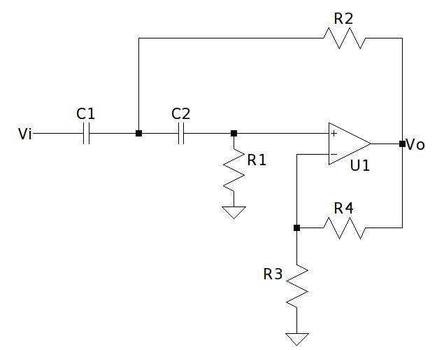

## 

## Multiple Feedback / Deliyannis - Friend

### Pasa bajo

[T. Deliyannis, “ High-Q factor circuit with reduced sensitivity,” Electron. Lett., vol. 4, pp. 577-579, Dec. 1968](https://drive.google.com/file/d/1lhCaylBJyXR7npror3HkfaOLDCaJSOJc/view?usp=sharing)

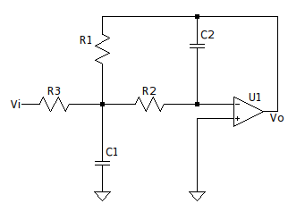

### 

### Pasa alto

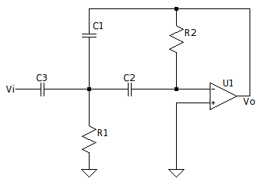

### 

### Pasa banda

### 

## 

## Ackerberg Mossberg

[D. Akerberg and K. Mossberg, "A versatile active RC building block with inherent compensation for the finite bandwidth of the amplifier," in IEEE Transactions on Circuits and Systems, vol. 21, no. 1, pp. 75-78, January 1974, doi: 10.1109/TCS.1974.1083785.](https://drive.google.com/file/d/1DgYNdDxkD1G-SLqivdPte2moQALQGp-Q/view?usp=sharing)

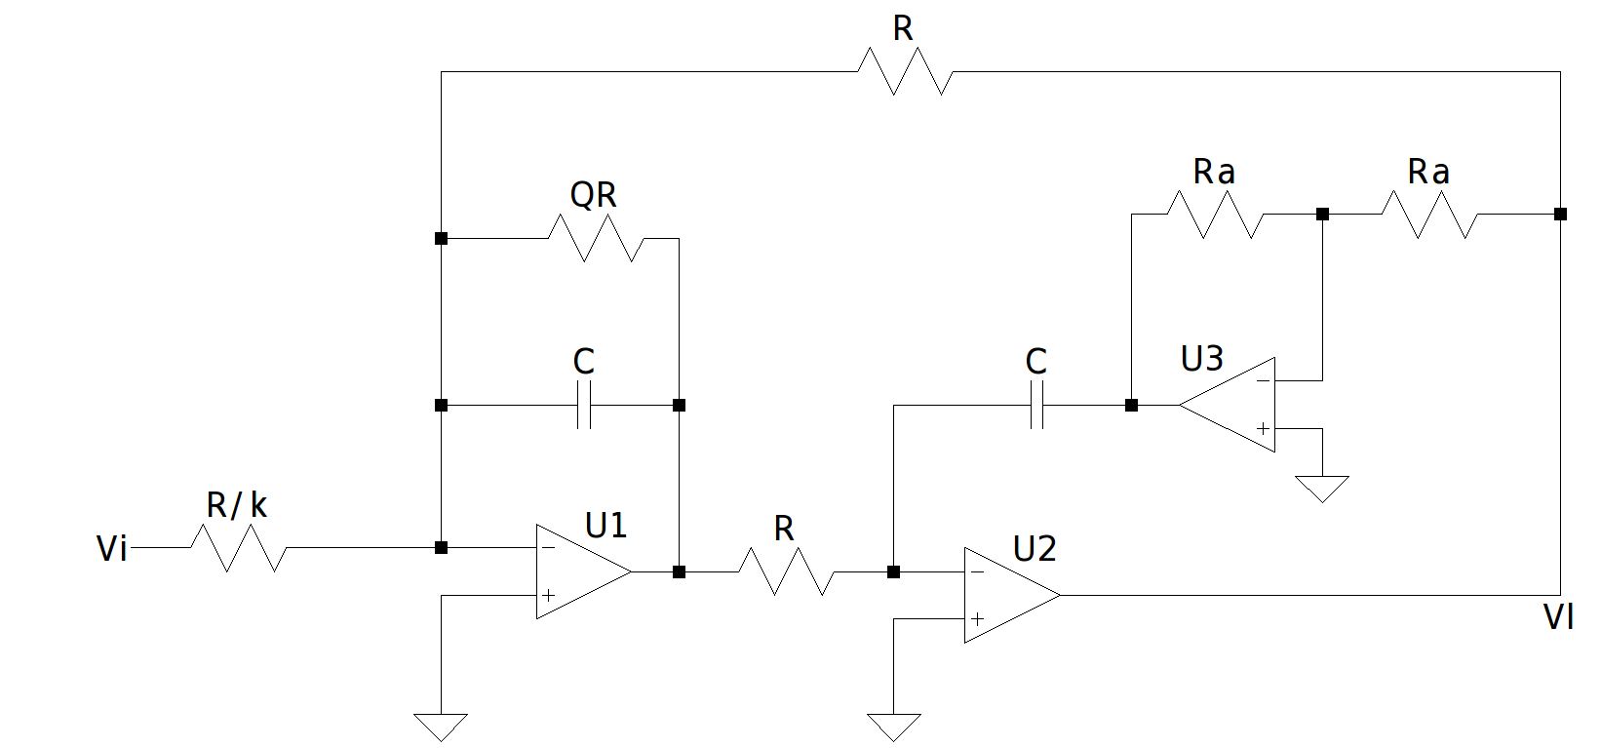

## 

## Variable de Estado / Tow-Thomas / Kerwin–Huelsman–Newcomb (KHN)

[W. J. Kerwin, L. P. Huelsman and R. W. Newcomb, "State-Variable Synthesis for Insensitive Integrated Circuit Transfer Functions," in IEEE Journal of Solid-State Circuits, vol. 2, no. 3, pp. 87-92, Sept. 1967, doi: 10.1109/JSSC.1967.1049798.](https://drive.google.com/file/d/1mhd0UNjekYjZbYfCN70e0I0dr-CDZGeZ/view?usp=sharing)

[State Variable Filters by Hank Zumbahlen, Analog Devices, Inc.](https://www.analog.com/media/en/training-seminars/tutorials/MT-223.pdf)

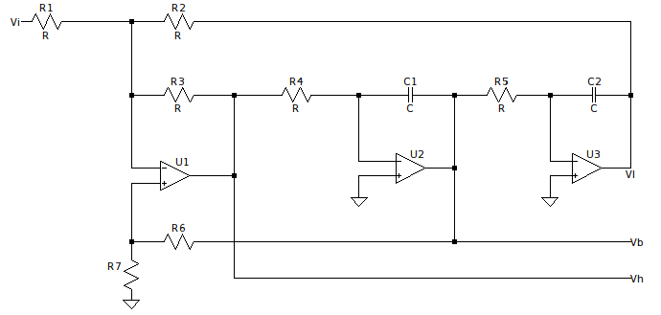

# 

# Estructuras con OTAs

## Filtro de segundo orden bicuadrático y canónico

[R. L. Geiger and E. Sánchez-Sinencio, "Active filter design using operational transconductance amplifiers: A tutorial," in IEEE Circuits and Devices Magazine, vol. 1, no. 2, pp. 20-32, March 1985, doi: 10.1109/MCD.1985.6311946.](https://drive.google.com/file/d/1urMpo0R047UCKFx9proeLOiCuw8gfg_0/view?usp=sharing)

